**Appendix**

Dispersing through Seasonal Landscapes

David D. Hofmann1,2,§ Dominik M. Behr1,2 John W. McNutt2

Arpat Ozgul1, 2 Gabriele Cozzi1,2

July 24, 2023

1. Department of Evolutionary Biology and Environmental Studies, University of Zurich,

Winterthurerstarsse 190, 8057 Zurich, Switzerland.

1. Botswana Predator Conservation Program, Wild Entrust, Private Bag 13, Maun,

Botswana.

§ Corresponding author (david.hofmann2@uzh.ch)

**Running Title:** Dispersing through Seasonal Landscapes

**Keywords:** dispersal, simulation, movement, integrated step selection function,

Kavango-Zambezi Transfrontier Conservation Area, landscape connectivity, Lycaon pictus

# A.1 Pan Mapping

We previously employed a floodmapping algorithm to generate weekly updated floodmaps, which allowed us to render the seasonal pulsing of the Okavango Delta. However, due to the coarse resolution of MODIS satellite imagery, based upon which the floodmaps were derived, prohibited a seasonal representation of more fine-scaled waterbodies, such as waterpans. In an attempt to overcome this limitation, we sought out and evaluated alternative satellite products that would provide better spatial resolution while still retaining sufficient temporal resolution to meaningfully render seasonal patterns. Candidate products comprised Landsat 7, Landsat 8, and Sentinel 2 satellite imagery, mainly because their data is freely accessible, provides a spatial resolution between 10 and 30 meters, and because the satellites have revisit times between 5 and 16 days, thus allowing to produce monthly updated images. A brief overview of the

While Landsat 7’s temporal availability would have aligned with the time window during which we collected GPS data on dispersing wild dogs, Landsat 7’s scan line detector has been failing since May 31 2003, resulting in data gaps between adjacent tiles, thus rendering this product unusable for our purposes.

With Landsat 8 and Sentinel 2 imagery remaining as viable candidates, we prepared a set of training polygons, consisting of the land cover classes *Dryland*, *Water*, and *Wet Pans*. Although our primary goal was to detect wet pans, we deliberately added additional classes, anticipating that their inclusion would facilitate the separation of reflectance values. Due to the large extent considered and limited time available in the field, *in situ* collection of training data was unfeasible and we instead opted for *on-screen selection* of training data. More specifically, we used Google Earth to digitize areas that were clearly identifiable as either dryland, water, or wet pan. At the highest zoom level that is allowed in Google Earth, these categories are visually easy to distinguish Figure S1. To verify a sharp distinction between wet and dry pans, we placed several dryland polygons on areas that are seasonally covered by water Figure S1. Depending on the area of interest, Google Earth displays highresolution satellite imagery collected on different dates, so assigned to each training polygon the date of acquisition of the displayed satellite image. This later allowed us to train the land cover classifier using Sentinel 2 or Landsat 8 data imagery acquired on the same dates. This procedure resulted in xx polygons (xx dryland, xx water, xx dry-pan, and xx wet-pan) distributed across xx dates.

To train a land-cover classifier, we selected 3’000 training points within the digitized training polygons following a stratified equal random sampling scheme (Shetty et al., 2021).

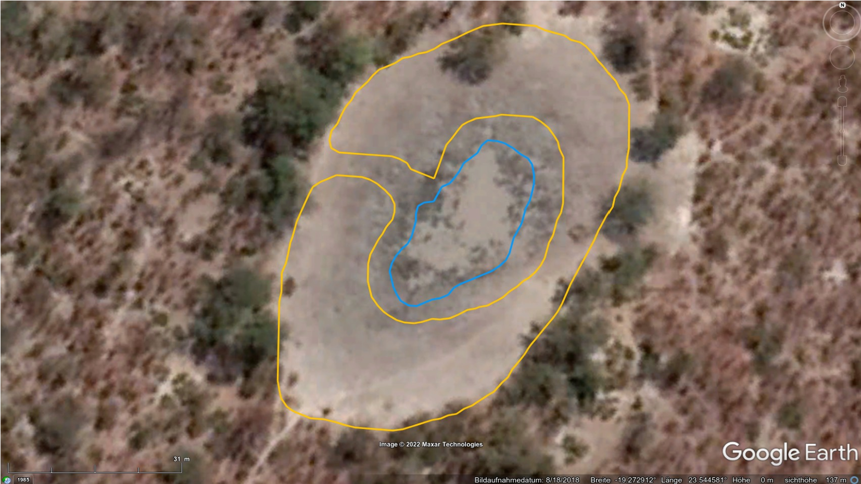

***Dryland***

*(*

*but seasonally inundated*

*)*

***Wet-Pan***

***Image aquisition date***

**Figure S1:** Example of a *wet pan* and *dryland* training polygon digitized on Google Earth. The extent of water can easily be gauged at this zoom level in Google Earth. While the dryland polygon in this case covered an area that is seasonally covered by water, other dryland polygons comprised areas that are never inundated. However, to ensure reliable differentiation between wet and dry pans, we included several dryland polygons located in dry pans.

That is, we ensured that a total of 1’000 random points per land cover category were generated. This was necessary to ensure that pans, which only accounted for a very small fraction of the study area, were sufficiently well sampled. In fact, stratified equal random sampling has been shown to provide good class-level accuracy for minority classes, so we deemed this approach suitable for our purposes. At each generated random point we then extracted reflectance values of Sentinel 2 and Landsat 8 bands that temporally aligned with the date assigned to the respective random point Figure S2. For instance, if a random point fell into a polygon that was digitized using a Google Earth image generated on Dec 18 2018, we extracted values from the Sentinel 2 and Landsat 8 composite for December 2018. Using the extracted values, we parametrized a Random Forest (RF) classification model.

To validate the predictive power of the RF classifier, we employed 5-fold cross-validation. For this, we split the data into 5 groups and repeatedly fitted the RF model using 80% of the data while predicting land cover categories on the remaining 20%. We then contrasted predictions with true classes and computed confusion matrices to obtain estimates of the classifier’s specificity, sensitivity, and overall accuracy. The results from this validation show that the RF classifier achieves very high overall accuracy, for both Landsat 8 and Sentinel 2 imagery Figure S3.

While both Landsat 8 and Sentinel provided very good results, we opted for Sentinel

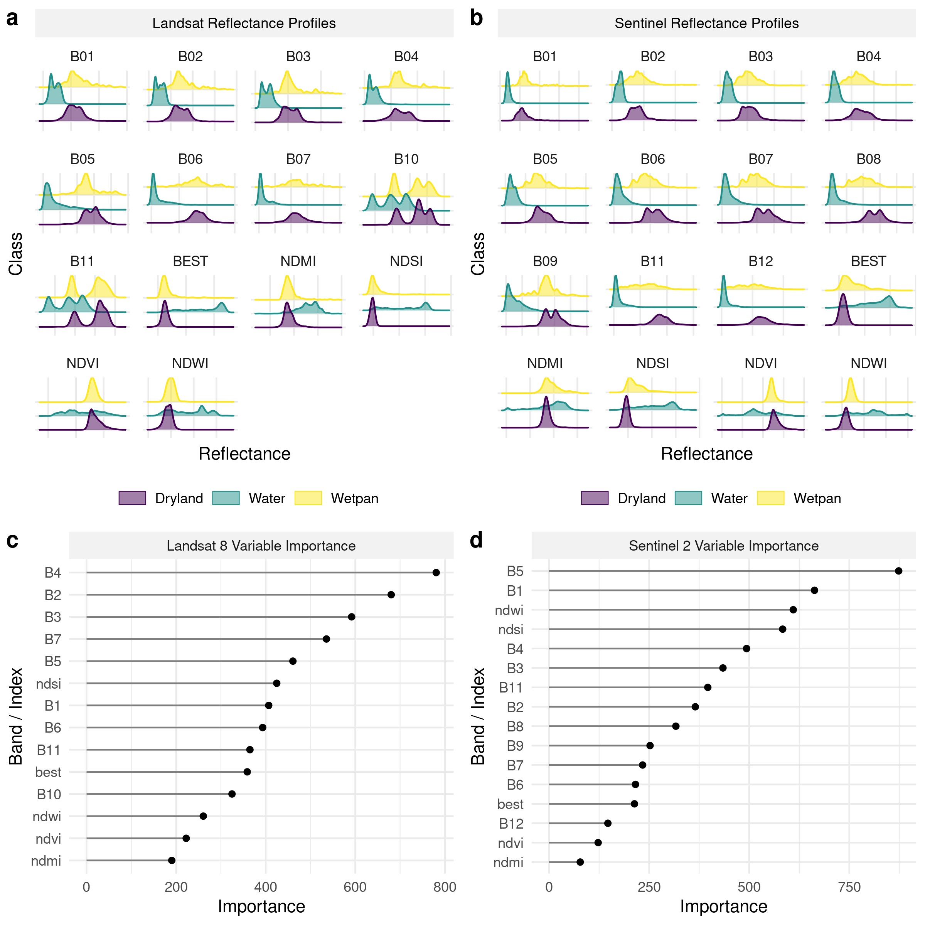

**Figure S2**

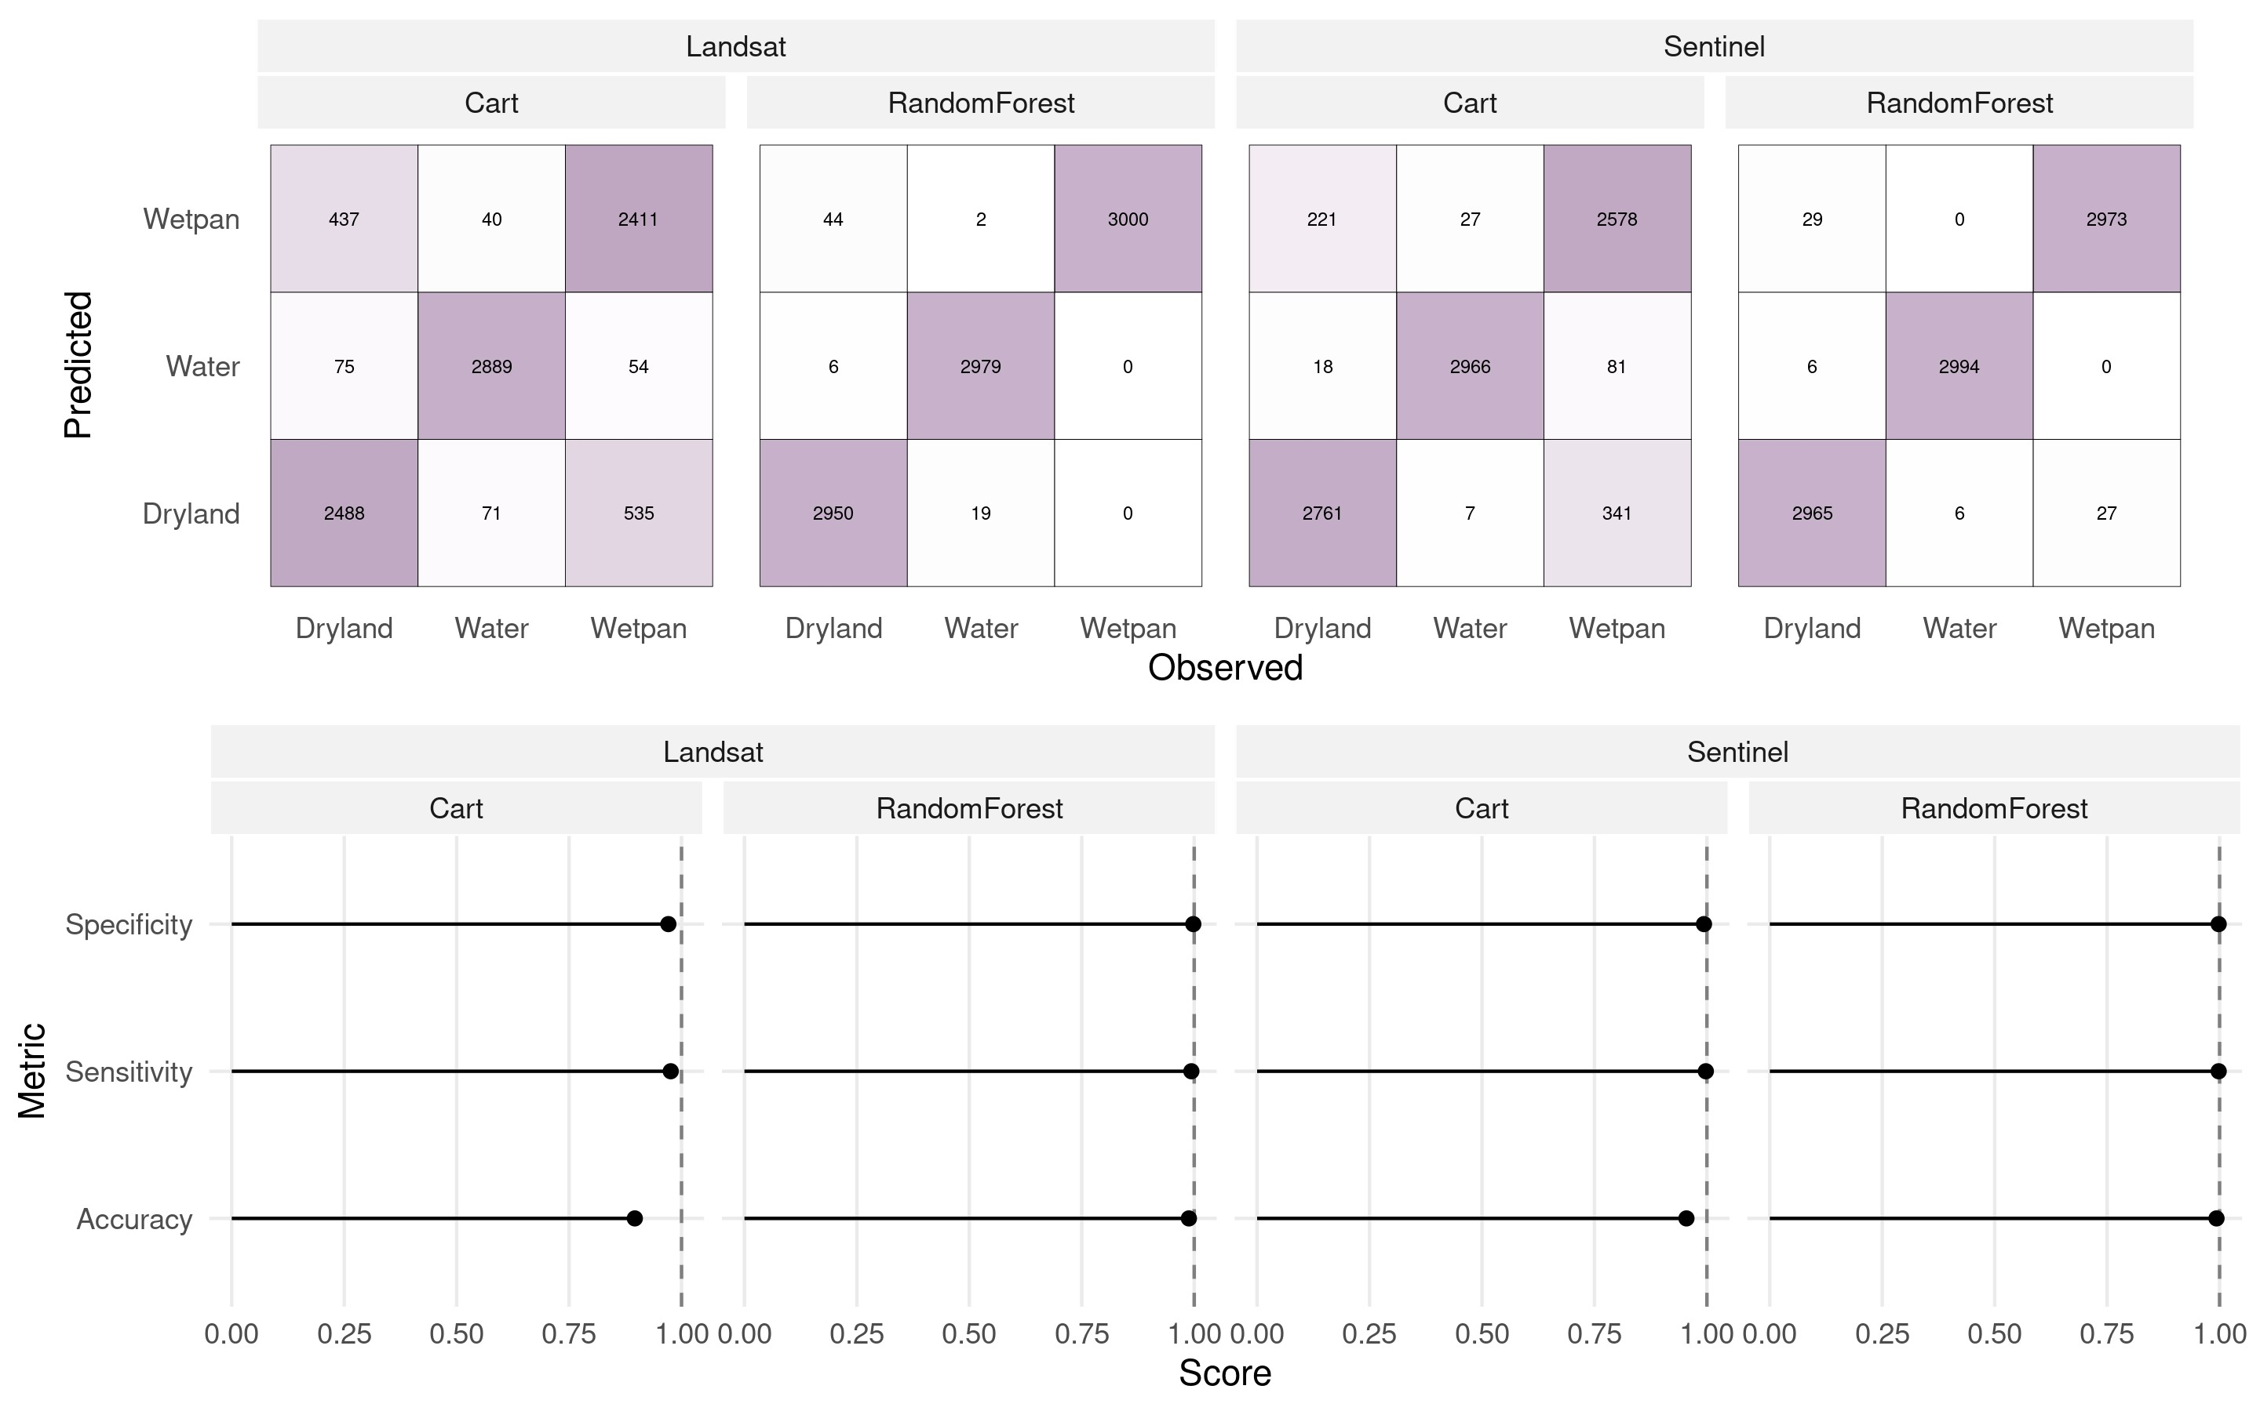

**Figure S3**

2 data, mainly due Sentinel 2’s better temporal coverage and marginally higher resolution, which we thought was crucial for pan detection. To download satellite imagery of interest, we first generated a spatio-temporal moving window comprising all GPS locations from dispersing wild dogs of a given month, buffered by 100km. We checked for intersections of each month’s moving window with Sentinel 2’s tile-grid and determined the tiles to be downloaded for every month. For the intersecting tiles, we then downloaded all available Sentinel 2 images falling into the respective month. Download and pre-processing of all Sentinel 2 images was achieved using the sen2r package in R. While atmospherically corrected Sentinel 2 data is currently being fed into ESA’s database, a large portion has not yet been processed from level 1C (top of the atmosphere, TOA) to level 2C (bottom of the atmosphere, BOA). Thus, whenever level 2C data was not available, we downloaded level 1C data and pre-processed the imagery into level 2C using sen2cor (Main-Knorn et al., 2017), again invoked through sen2r (Aybar, 2023).

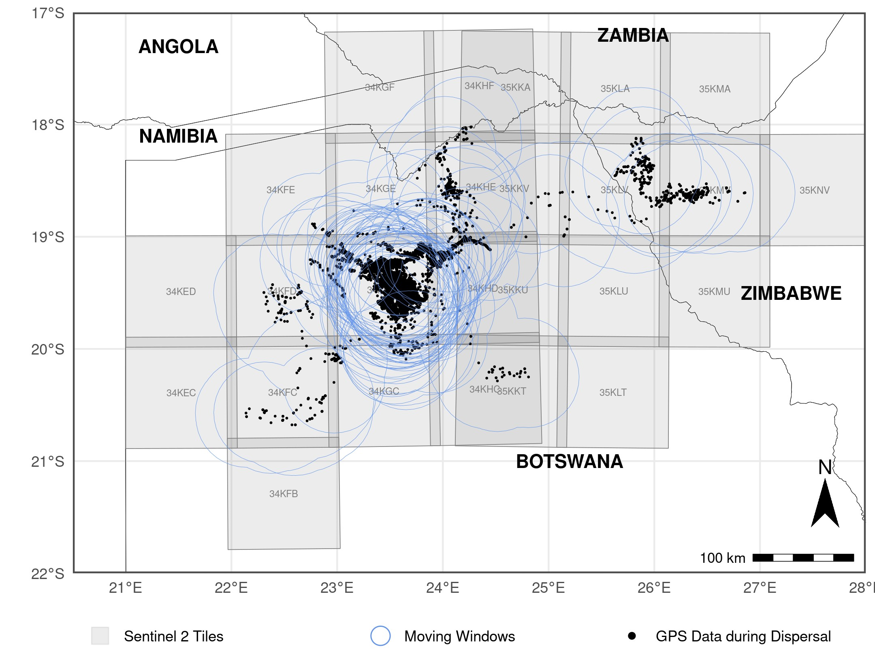

**Figure S4**

# References

Aybar, C. (2023). Rgee: R Bindings for Calling the ’Earth Engine’ Api.

Main-Knorn, M., Pflug, B., Louis, J., Debaecker, V., Mu¨ller-Wilm, U., and Gascon, F. (2017). Sen2Cor for Sentinel-2. In Bruzzone, L., Bovolo, F., and Benediktsson, J. A., editors, *Image and Signal Processing for Remote Sensing XXIII*, page 3, Warsaw, Poland. SPIE.

Shetty, S., Gupta, P. K., Belgiu, M., and Srivastav, S. K. (2021). Assessing the Effect of Training Sampling Design on the Performance of Machine Learning Classifiers for Land Cover Mapping Using Multi-Temporal Remote Sensing Data and Google Earth Engine. *Remote Sensing*, 13(8):1433.